**INSTRUCTIONS:**

The objective of this experiment is to earn as many points as possible by correctly choosing between two targets. A certain number of points corresponds to a certain amount of money you earn, the sum of which you will collect at the end of the experiment. In this experiment, 10 points earns you 25 cents.

You will see targets that have different colors and shapes. Color, shape, or some combination of the two will predict how likely it is that you’ll get a reward from the target, but it’s up to you to figure out the rule.

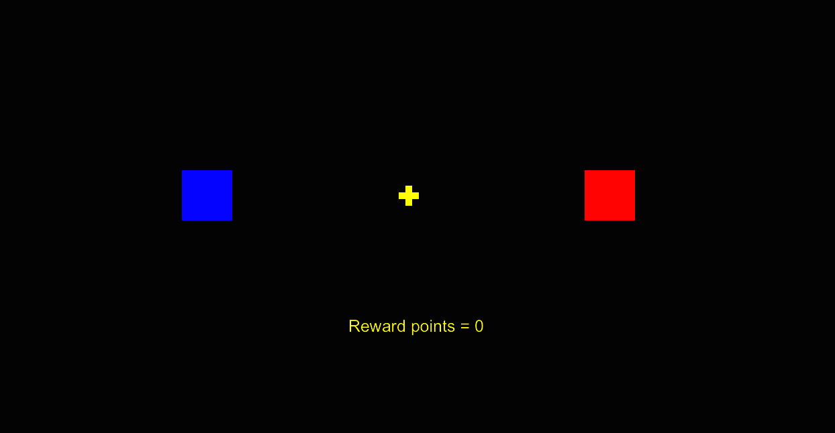



The rule may change over time. The reward is probabilistic, which means that even if you follow the rule you will not always get reward. Your goal is to get as many reward points as possible, and you will be paid based on your performance. You can use the left and right arrow keys to select the target.